AMBER MANUFACTURE POLAND

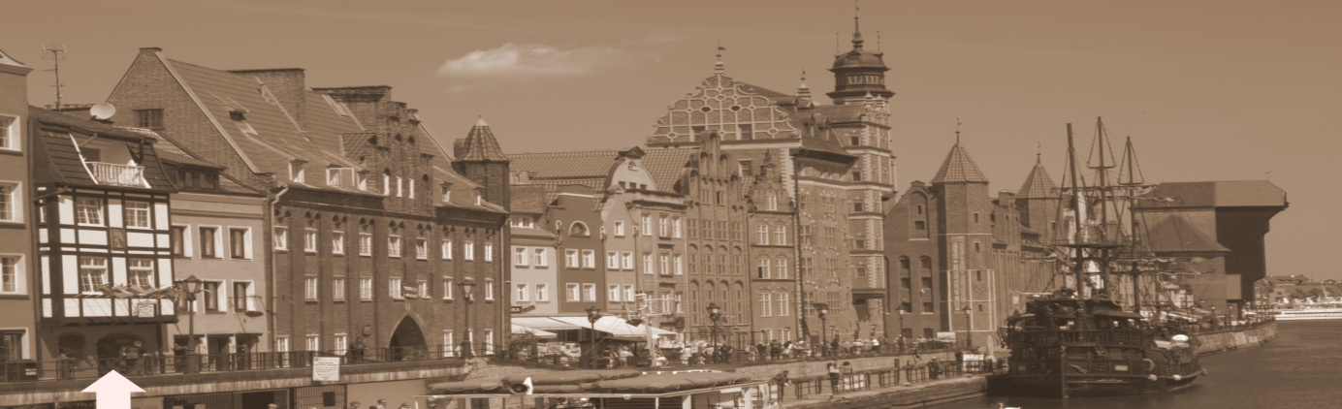

Would you like to see the three generations of contemporary Gdańsk inhabitants? Come and visit unique Patrician house in the very heart of Gdańsk Main Town and see how its residents live and work here.

You are welcome to visit open for visitors Amber Manufacture Poland in Gdańsk Main Town dating back to 1893.
It is the oldest amber workshop in Gdańsk located on the legendary Amber Road.

Visitors have the rare opportunity to:
- enter a unique jewelry workshop
- see the amber and silver processing
- see polishing amber show with a unique opportunity to grind a piece of amber yourself supervised by an Amber Master
- get to know methods how to distinguish genuine amber from the fake one
- learn the history of amber art, craftsmanship tradition from Ancient times up to now
- see presentation of unique amber inclusions
- and unique jewels exhibition
- repast provided by AMP company

Amber Manufacture offers also a possibility to purchase amber products at special factory prices on the spot!

Amber presentation lasts about 1 hour and is paid.
Workshop is open Monday – Friday from 10 am till 6 pm.
Amber shows made on Saturday and Sunday on prior request.
The workshop is conveniently located in the very heart centre, easily accessible for the pedestrians as well as for boat and car passengers.
Unfortunately, we do not provide interpreting services in foreign languages for your visitors.
Please, register group visit in advance.

A visit in our manufacture requires a prior reservation.

AMBER MANUFACTURE POLAND
80-888 GDAŃSK, ul. Długie Pobrzeże 4
tel/fax: +48 58 301 78 64
www.ambermanufacture.com.pl
michel@ambermanufacture.com.pl

